**FAS News Letter No. 1**

**24. September 2010**

**During this summer, several adjustments were made within the maritime sector in the Faroe Islands, all with the same immediate purpose of adjusting the authorities to meet the greater challenges and to strengthen the FAS position in the future.**

**Merger of the ship register FAS and the maritime authority FMA**

1st of June 2010 the Faroese National & International Ship Register was merged with the Faroese Maritime Authority.

The two administrations have always been working closely together, so it was a logical step to implement this merger. It is practical for the administration as well as for the shipowners that these maritime activities are now under joint management. We can hereby ensure a consistent policy and commit ourselves also in the future to give shipowners a smooth and effective service on all levels, as well as we will hold on to our commitment to international maritime obligations.

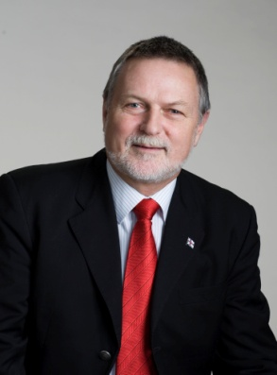 

Mr. Tommy Petersen Mr. Vilhjálmur Gregoroussen

Mr. Tommy Petersen is assigned Director General of the Faroese Maritime Authority **FMA** with Mr. Vilhjálmur Gregoriussen as Deputy Director.

The joint authority will continue under the name FMA – the Faroese Maritime Authority – as well as we will keep the FAS brand.

**Adjusted registration fees**

1st of July 2010 adjustments were made on registration fees

As a way of making the registration fees to become even more transparent, the registration fee is no longer based on the insurance policy. The registration fee is now calculated on ship size only.



**During the last years the Faroese Maritime Authority has, in close co-operation with the shipowners, intensified its work on improving FAS ships’ performances on Port State Controls in order to improve the Faroese flag’ position on the Paris MoU List of Port State Control. This has resulted in the Faroese flag consistingly climbing the Grey List. It is our goal to enter the White List in 2011.**

**Introduction of annual fees**

1st of July 2010 annual fees were levied on FAS ships.

The annual fees now levied on FAS ships will help financing an upgrade of the legal and surveying departments of FMA in order to further develop our service level and commitment towards shipowners and authorities.

The size of the annual fee is composed of *a basic fee of DKK 15,000 + (GT x GT factor) x percentage* *fee* calculated on the ship gross tonnage and age.

|  |  |  |
| --- | --- | --- |
| **Gross Tonnage (GT)** | | **DKK per GT** |
| **From** | **To** |
| 0 | 3,000 | 1.3 |
| 3,001 | 7,500 | 1.0 |
| 7,501 | 24,000 | 0.7 |
| 24,001 | 30,000 | 0.5 |
| 30,001 | 45,000 | 0.4 |
| 45,001 | And above | 0.3 |

|  |  |  |
| --- | --- | --- |
| **Percentage based on age** | | |
| **From** | **To** | **%** |
| 0 | 4 | 0 |
| 5 | 9 | 5 |
| 10 | 14 | 10 |
| 15 | 19 | 15 |
| 20 | 24 | 20 |
| 25 | 29 | 50 |
| 30 | 49 | 75 |
| 50 | And above | 100 |

Below are shown examples of annual fee for three vessels – different size and age

|  |  |  |  |  |  |  |  |  |  |
| --- | --- | --- | --- | --- | --- | --- | --- | --- | --- |
| Gross tonnage | | Built | **Years** | **Basic fee** | **+** | **GT x GT factor** | **x** | **Percentage fee** | **Annual Fee** |
| Ship GT | 1051 | 2008 | 2 | 15,000 | + | (1051 x 1,3) | x | 1 | DKK 16.366 |
| Ship GT | 9382 | 1994 | 16 | 15,000 | + | (9382 x 0,7) | x | 1,15 | DKK 24.803 |
| Ship GT | 35966 | 2003 | 7 | 15,000 | + | (35966 x 0,4) | x | 1,05 | DKK 30.856 |